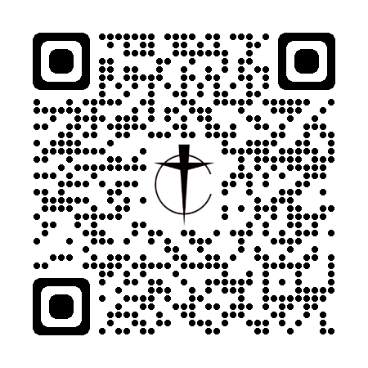

**Chester Cursillo Weekend Application Form**

Each Cursillo weekend in Chester Diocese starts at 5pm on a Friday and runs through to 6pm Sunday afternoon. In order to reap the full benefit of this unique experience, please bear in mind you will be expected to be with us for the whole weekend.

**Companionship**

All aspects of a Cursillo weekend are supported by prayer. Therefore, we arrange for appropriate existing members to support new members before, during and immediately after their attendance at a weekend. The person chosen by us to act as your companion will be in touch to provide you more detailed information and support, including advice about travelling to & from the weekend.

As a matter of courtesy, our Diocesan Spiritual Director will contact your parish priest in advance of the weekend, to let them know that you have applied to come on a weekend and invite them to join us in praying for you.

**Funding of Cursillo**

Chester Cursillo Weekends are fully funded from money has already been donated to us. Each weekend is a gift to the participants who will have the opportunity to make a donation towards the cost of future weekends for others, although there is **absolutely no obligation** to do so.

Although the weekend is free, we do ask for a deposit of £20. This deposit is not normally refundable if you cancel your attendance less than six weeks before the date of the Weekend.

If payment of the deposit would present you with particular difficulty, please speak, in confidence, to our Weekend Co-ordinator (see below), who can make alternative arrangements with you.

**The Venue**

Currently Chester Cursillo Weekends are held regularly at Foxhill which is the Chester Diocesan Conference Centre, near Frodsham. Our next Weekend runs from 25th-27th October 2024.

**After the Weekend**

After the weekend you are invited to continue your Christian life together with other Cursillistas; this ongoing mutual support and encouragement is the most valuable part of Cursillo. We meet regularly in both local small groups and occasionally across the wider diocese and beyond.

**To apply**

Please complete and return this form as soon as possible to **Veronica Hydon** [weekend-coordinator@chestercursillo.org.uk](mailto:Weekend-coordinator@chestercursillo.org.uk) or post to **6, Merlin Close, Macclesfield SK10 2AS** along with your deposit of **£20.00** preferably via bank transfer to:

|  |  |  |  |
| --- | --- | --- | --- |
| Account Name: **Cursillo Chester** | Sort Code: **08-92-99** | Account No: **65883039** | |
| Please include your **surname** followed by the number **65** as the payment reference  If you cannot make an electronic transfer, then cheques should be made payable to Cursillo Chester. Thank you.  The next weekend is from the **25th-27th October 2024** | | | |

Please note the deadline for applications to join weekend 65 is the**13th September 2024**

Your application will be acknowledged by email where possible, and further details, including directions to the venue, will be provided a few weeks before the date of the Weekend.

**Further information** can be found at: [www.chestercursillo.org.uk](http://www.chestercursillo.org.uk) (QR code at the top of the page)

